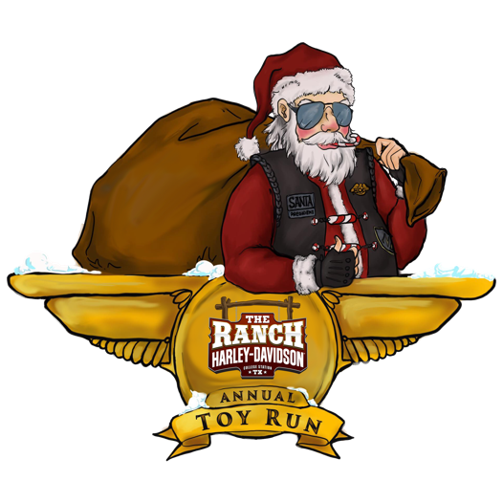
Howdy!
My name is Alex Gipson-Mills and I am the Marketing & Toy Run Director at The Ranch Harley-Davidson. I wanted to reach out to you about our non-profit, the Brazos de Dios Harley Owners Group Foundation! If you are not familiar with our organization, I am more than thrilled to explain! Since we truly are unlike any other holiday charity, it’s a little difficult to put everything we do in this letter, so I will attempt to summarize as much as I can! The Annual Toy Run began in 1988 by Russ & Sharon Welch, to assist the struggling families in our local community. Little did they know, they were able to set in motion an ongoing tradition for the last 32 years, that’s been able to continue through 3 ownership changes and assist over 400 of the neediest families in Bryan-College Station. When we took over the Foundation in 2016, we’ve been more than honored to continue on, with the hopes of taking it to new heights.
This year, like most Non-Profit Organizations, we’ve struggled to raise funds for our Toy Run. With the cancellation of all of our major fundraising events, we are reaching out in high hopes that we will be able to raise enough money to keep our tradition going this December. We all know Covid-19 has made significant impacts on our local community and there’s a very good chance that anyone struggling before the pandemic, will truly need our help now more than ever!
This year will definitely look different for us, but as I mentioned earlier, we are uniquely different from most “toy run” type groups. Our first step is reaching out to our local schools, churches, and organizations to receive family nominations. Even though every year is different, we typically get at least 80 nominations. After our in-depth interviewing process, we choose 12-15 families, giving top priority to Veteran families, single-parent households, and those who have gone through a recent & significant traumatic experience. I keep saying “families” because we do not just help the children. We are usually (on a normal year) able to provide furniture, mattresses, clothing, basic necessities, for the entire household. In recent years, we have been able to partner with other local businesses such as, Ashley Furniture HomeStore, Sleep Station, D&D Moving & Storage, to give our families a Christmas that they would not have otherwise. With that being said, we are constantly looking for new sponsors, donations, and assistance. Below, I have listed several ways you or your business can help this 32-year tradition continue:

- Monetary Donations- Every single penny we raise goes to buying our families the things they need. The attached donation form explains the different levels of sponsorship and how you can benefit by giving!
- In-Kind Donations (goods, food vouchers, services, etc. for our families)

- Silent Auction items for our month-long November Fundraiser and/or Live Auction Items for our final Fundraiser of the year on December 5th, 2020 (tentative based on COVID-19 regulations)
- Set up a collection box at your business. Collections can include canned food, lightly used stuffed animals, and/or money. I can provide everything needed for setup!

Simply put, we cannot continue without the help of our community. We are asking you to reach deep down in your pockets this Christmas season, and help us give back to those who deserve it!
In all cases, your donation of any kind will be recognized by Company Name or Individual Name on The Ranch Harley-Davidson social media sites and our Toy Run website! Please visit www.trhdtoyrun.com for complete information on the Toy Run, sponsor list, and more! For suggestions or questions, please give me a call or email!
I greatly appreciate your time and consideration! I hope to hear from you soon.
Warm regards,

Alex Gipson-Mills
Director- 2020 TRHD Toy Run
Marketing Director- The Ranch Harley-Davidson
(979) 690-1669 or alex@theranchhd.com

Susan Gipson
Assistant Director- 2020 TRHD Toy Run
Owner- The Ranch Harley-Davidson
(979) 690-1669 or susan@theranchhd.com

